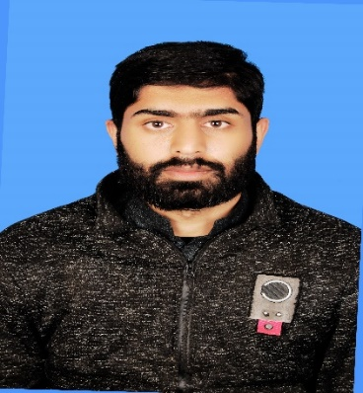 malikahmadhassan12345@gmail.com

**AHMAD HASSAN**

IRMNCH H.N.142 G.C.01 Sialkot

Phone#:0301-5629635

DOB:03/09/1999

Gender: MALE

Nationality: PAKISTANI

CNIC#: 3706-6459109-5

-----------------------------------------------------------------------------------------------------------------------------------------

**Objective:**

Respectively Secured a position for my job in which a note taken a look use to go to check my purpose of hiring process Where I can utilize my experience for work to Find Possible Solution may put my full effort on the Work I can do try my best by myself. As well as in this general Level Enhance Impressive learning about to be learn a lot of Great knowledge and awareness, Keep leading up to found yourself to emerging in this for the best.

------------------------------------------------------------------------------------------------------------------------------------------

|  |
| --- |
| **COMSAT Institute of Information and Technology Islamabad(CIIT), WAH Campus**  **Marks Obtained In 2.3 CGPA Years (2017-2022)**  **F.G. Science Degree College For Men, WAH**  **Marks Obtained In 661/1100 60% Years (2015-2017)**  **F.G. Model High School, WAH**  **Marks Obtained In 730/1050 70% Years (2015)** |

**Education:**

* Bachelors-In-Computer Science
* Intermediate(FCS)
* Matric (Computer Science)

------------------------------------------------------------------------------------------------------------------------------------------

**Skills & Working Experience:**

IT Specialized in Artificial Intelligence………….

AI Core field Digital Image Processing and Machine Learning…………1Year Working Experience

WEB DEVELOPMENT Frontend/Backend…………1year Working Experience

i.e... MS Office,DBMS,MYSQL,.net, Intermediate python, CSS, HTML, java

i.e... Computer Hardware Knowledge, Computer Software knowledge

------------------------------------------------------------------------------------------------------------------------------------------

**Languages:**

* URDU
* ENGLISH
* FRENCH

**Achievements:** IEEEXtreme 24 hour Programming Competition